
COMSATS UNIVERSITY, ISLAMABAD
Department of Computer Science
Lab Final Examination, Spring-2026

Course: Database Systems (CSC270) Class: BSCS-III
Instructor: Rubina Adnan Total Marks: 50

Instructions:

2- You need to submit the solution for each of the parts in a well-formatted document.

lab Final term [50]
Solve all the given questions by considering the Database management project proposed by you. (Group members not more than 3).
The submission will include a document containing a description of the system, ER and EER diagrams and the queries output.
Submission of will be on 20 May 2026
[CLO5] Apply data processing operations on both relational and non-relational DBMS.
Part-I: Represent the relational database with normalized tables (up to BCNF). Implement the EER constraints 1-1, 1-many, many to many, “U”, “O”, “d”, “Partial participation”, “Total participation”, multi-attribute, super-class, sub-class, multiple-inheritance. Users can access data and perform all crud operations from the GUI [10+5]
Part-Ia: Insert a few meaningful tuples in the resultant relations [5]
Part-Ib: Now in this part, you are going to first create a meaningful query in English and then in SQL for each of the following situations: [5]
- Think of a need that involves the use of a sub-query.
- Think of a need that involves the need to use any of the set operators.

Part-II: Convert the (Relational database into non-relational database). Create a JSON file. and import it from the mongo DB compass. a JSON file that includes various **constraints** typically used to define and validate data. Constraints such as data types, required fields, length limits, and value ranges are specified in this structure: ### JSON File Example: Employee Database ```json { "employees": [ { "id": { "type": "integer", "constraints": { "required": true, "unique": true, "minValue": 1 } }. [10]
Part-IV: Insert a few meaningful tuples in the resultant relations. [5]
Part-V: User can access data and perform all crud operations from the GUI.[5]
Part-VI: Now in this part, you are going to first create a meaningful query in English and then in MQL for each of the following situations: [5]
- Think of a need that will require joining at least 2collection.
- Think of a need that will require access to data from different collections using aggregate functions (or create a pipeline with multiple stages).

Evaluation Criteria You will initially be evaluated using the marking criteria defined above against each of the tasks. After the submission, a viva voce will be conducted to evaluate your understanding of the submitted solution. The following percentages will then be applied on top of the marks obtained to determine the final marks.
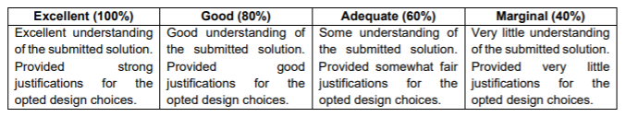
For example, if you obtain 20 marks out of 25 based on your submitted solution, and then during viva if you only have marginal understating of it, you will eventually get 20*40% = 8 marks out of 25.

--------------------------------------------------------

